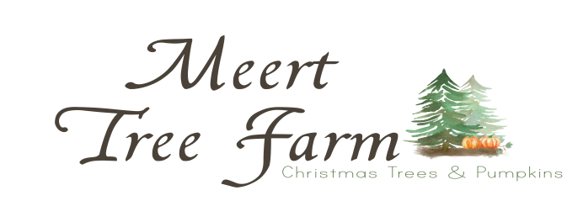
Photography
Waiver

Photographer/ Name of Business: _________________________________________________________
Address: ______________________________________________________________________________
City: __________________________ State: ___________________ Zip Code: ______________________
Phone: _________________________ Email: __________________________________________________
Client(s) Name(s): _________________________________________________________________________ _____________________________________________________________________________________________________________________________________________________________________________________________________________________________________________________________________________
Date and Time: __________________________________________________________________________
# Of Sessions ($40 per secession):__________ OR Unlimited Sessions ($125 per day):____________
I hereby release that Meert Tree Farm, its staff, and its members from any liability or injury that I or my client(s) may sustain during my photography session at the Farm. In case of illness or injury occurring on Meert Tree Farm property and in the event that I, or my client(s) are unable to respond, I authorize the staff members of Meert Tree Farm to arrange emergency medical treatment or transportation to a hospital for myself or my client(s). The Photography fee is non-refundable and if there is a weather issue, a reschedule date will be decided on. All secessions MUST be paid online no later than 48 hours in advance, and this waiver must be emailed to MeertTreeFarm@gmail.com, no later than 24 hours in advance. If there is any damage done to the fields during my photo secession, I am responsible for covering those costs.
Photographer’s Name (Printed):__________________________________________________________
Photographer’s Signature: __________________________________________Date:________________

